How does it work

# Purpose

The eventual intent of this page is to provide a high level overview of how the Content Interface works. The content here is still a work in progress.

1. Add the Content Interface to a Blackboard page.
2. Create and edit content in a Word document.
3. Convert that Word document into HTML and place it into Blackboard.

# Add the Content Interface to a Blackboard Page

To use the Content Interface you must add at least two (three is recommended) Content Interface items to a Blackboard page. The image below shows all three components, including:

* Content Interface;  
  An empty [Blackboard content item](https://utlv.screenstepslive.com/s/faculty/m/BlackboardLearn/l/185559-creating-a-content-item) that will eventually contain the HTML generated by the Content Interface.
* Content Management Instructions; and,  
  A content item that contains [this collection](https://raw.githubusercontent.com/djplaner/Content-Interface-Tweak/master/tweak.html) of HTML and Javascript. These are the instructions that make all the components of the Content Interface work. When fully displayed it will also show some human instructions for how to use the Content Interface.
* Content Document (optional).  
  This is optional component is [a Blackboard web link](https://help.blackboard.com/Learn/Instructor/Course_Content/Create_Content/Create_Course_Materials/Link_to_Websites). It contains a shared link to the Word document that contains the content for this page. The presence of this component simplifies the process of updating Blackboard.

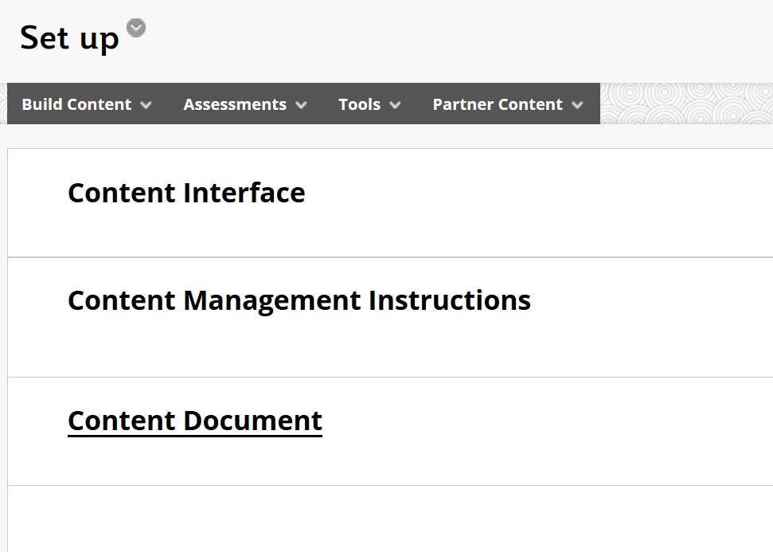

Figure 1 - Three components of a Blackboard page with the Content Interface (edit mode on)

## What the students see is different

Figure 1 is the view when [*Edit mode*](https://elearn.southampton.ac.uk/blackboard/quickedit/) is on. It’s what teaching staff can see. Students see a different view (*Edit mode* off). The differences are shown in the image below. For students, the *Content Document* and *Content Management Instructions* items will be invisible. The title of the *Content Interface* item will also be hidden from them.

Students would normally see any other items on this page and the content included within the *Content Interface* item. The page in these images currently doesn’t have either.

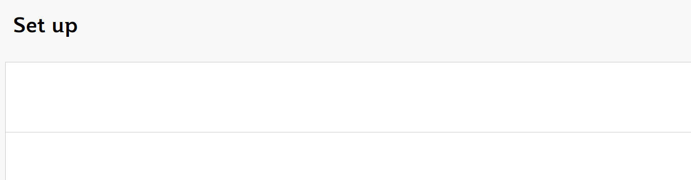

Figure 2 - Same page as Figure 1 but with edit mode off (what the students see)

# Create and edit content in a Word document

**Never** edit Content Interface content in Blackboard.

When using the Content Interface, all content creation and editing should be done in the associated Microsoft Word document.

The Word document should use both normal Word styles (e.g. *Heading 1*, *Heading 2*, *Quotations* etc.) and some content interface specific styles (e.g. *Embed*, *Activity*, *Reading*, etc.) to structure the content of a Word document. (The following paragraph has been styled with the *Activity* style)

**Find out more about Word styles**

If you’re unfamiliar with using styles in Word documents, please refer to the plethora of online resources (e.g. [this one](https://shaunakelly.com/word/styles/tipsonstyles.html)). A quick search for *introduction word styles* should find most.

# Convert that Word document into HTML and place it into Blackboard

Blackboard Learn is a web-based application. Any content it displays needs to be in the [HyperText Markup Language (HTML)](https://en.wikipedia.org/wiki/HTML). Before the content in the Word document can be displayed in Blackboard Learn, it must be converted to HTML.

Depending on whether or not your Content Interface page includes the *Content Document* item (explained above) the Content Interface provides two methods to convert the Word document to HTML. A manual and semi-automated method. The *Content Management Instructions* item will always provide instructions on the appropriate method to use.

## Manual method

*To be done*

## Semi-automated method

<iframe src="https://griffith.h5p.com/content/1291061357553202529/embed" width="1088" height="637" frameborder="0" allowfullscreen="allowfullscreen" allow="geolocation *; microphone *; camera *; midi *; encrypted-media *"></iframe><script src="https://griffith.h5p.com/js/h5p-resizer.js" charset="UTF-8"></script>